A

**Semester Project-II Report**

**On**

**“Online Voting System”**

### By

1. Ram Girish Paliwal
2. Puja Prabhakar Borse
3. Kanchan Prakash Mahajan
4. Lalit Gulab Sangore



## Department of Computer Science & Engineering (Data Science)

**The Shirpur Education Society’s**

# R. C. Patel Institute of Technology, Shirpur - 425405.

**[2021-22]**

**A**

**Semester Project-I I Report On**

**­­­“Online Voting System”**

In partial fulfillment of requirements for the degree of Bachelor of Technology

In

Computer Science & Engineering (Data Science)

##### Submitted By

1. Ram Girish Paliwal
2. Puja Prabhakar Borse
3. Kanchan Prakash Mahajan
4. Lalit Gulab Sangore

##### Under the Guidance of

Prof. Sagar. U. More



**The Shirpur Education Society’s**

**R. C. Patel Institute of Technology, Shirpur - 425405.**

**Department of Computer Science & Engineering (Data Science)**

**[2021-22]**



**The Shirpur Education Society’s**

**R. C. Patel Institute of Technology Shirpur, Dist. Dhule (M.S.)**

**Department of Computer Science & Engineering (Data Science)**

***CERTIFICATE***

This is to certify that the Semester Project-II- Online Voting System**”** has been carried out by team:

1. **Ram Girish Paliwal**
2. **Puja Prabhakar Borse**
3. **Kanchan Prakash Mahajan**
4. **Lalit Gulab Sangore**

under the guidance of **Prof. Sagar. U. More** in partial fulfillment of the requirement for the degree of Bachelor of Technology in Computer Science & Engineering (Data Science) (Semester-IV) of Dr. Babasaheb Ambedkar Technological University, Lonere during the academic year 2021-22.

##### Date:

**Place: Shirpur**

**Guide Semester Project-I Coordinator**

**Prof. Sagar. U. More Prof. S. S. Sonawane**

**H.O.D. Director**

**Prof. Dr. Nitin N. Patil Prof. Dr. J. B. Patil**

**ACKNOWLEDGEMENT**

We are grateful and sincerely appreciate the effort of our respected project in-charge **Prof. Sagar. U. More** who acted as a fulcrum for us and supported us during the ups and downs of our project. We are profoundly indebted to our project guide **Prof. Sagar. U. More** for innumerable acts of timely advice, encouragement and we sincerely express our gratitude to him.

We extend our sincere thanks to **Prof. Dr. R. B. Wagh**, Head of Department, Computer Engineering, for providing us the right ambience for carrying out this work.

Many people have contributed to the success of this project work. Although a single sentence hardly suffices, we would like to thank Almighty God for blessing us with his grace. We would like to express my sincere appreciation to our Principal, **Dr. J. B. Patil**, who spend his precious time and gave some ideas and suggestion towards this project. We express our immense pleasure and thankfulness to all the teachers and staff of the **Department of Computer Science and Engineering (Data Science)** for their cooperation and support.

`

**Project Team:**

**1.Ram Girish Paliwal**

**2.Puja Prabhakar Borse**

**3.Kanchan Prakash Mahajan**

**4.Lalit Gulab Sangore**

##### Chapter Topic Page No.

|  |  |  |  |
| --- | --- | --- | --- |
|  | | ABSTRACT |  |
| **1.** |  | Introduction | 1-7 |
|  | 1.1 | About Languages |  |
|  | 1.2 | PHP Features ­­PHP's |  |
|  | 1.3 | PHP Programming Languages |  |
| **2.** |  | Literature Review |  |
|  | 2.1 | Problems with the Existing Voter Registration System |  |
|  | 2.2 | Security issues of online voting |  |
| **3.** |  | Related Work | 8-9 |
|  | 3.1 | Background of Study |  |
|  | 3.2 | Significance of Study |  |
|  | 3.3 | Architecture |  |
| **4.** |  | Software And Hardware Requirements | 10 |
|  | 4.1 | Software Requirements |  |
|  | 4.2 | Hardware Requirements |  |
| **5.** |  | Implementation Details | 11-14 |
|  | 5.1 | Front– End and Back-End |  |
|  | 5.2 | Data Base Tables |  |
|  | 5.3 | ER Diagram |  |
|  | 5.4 | Snapshots of Outputs |  |
|  | 5.5 | Advantages |  |
| **6.** |  | Conclusion | 15 |
|  |  | BIBLIOGRAPHY |  |

**Table Table No.**

* 1. Software Requirements

##### Page No.

10

* 1. Hardware Requirements 10
     1. Admin Table

5.2.2 Voter Table

5.2.3 Candidate Table

##### Fig. No Figure Page No.

5.3 ER Diagram of OVS

5.4.1 Log In Page 13

5.4.2 Registration Page

5.4.3 Home Page

5.4.4 Voting Page

**ABSTRACT**

*The word “vote” means to choose from a list, to elect or to determine. The main goal of voting (in a scenario involving the citizens of a given country) is to come up with leaders of the people’s choice.*

*Most countries, Kenya not an exception have problems when it comes to voting. Some of the problems involved include ridging votes during election, insecure or inaccessible polling stations, inadequate polling materials and also inexperienced personnel.*

*This online voting/polling system seeks to address the above issues. It should be noted that with this system in place, the users, citizens in this case shall be given ample time during the voting period. They shall also be trained on how to vote online before the election time.*

### CHAPTER – 1

**Introduction**

In this Project people who have citizenship of Kenya and whose age is above 18 years of age and any sex can give his\her vote online without going to any physical polling station. There is a database which is maintained in which all the names of voters with complete information is stored.

In “ONLINE VOTING SYSTEM” a voter can use his\her voting right online without any difficulty. He\She has to be registered first for him/her to vote. Registration is mainly done by the system administrator for security reasons. The system Administrator registers the voters on a special site of the system visited by him only by simply filling a registration form to register voter. Citizens seeking registration are expected to contact the system administrator to submit their details. After the validity of them being citizens of India has been confirmed by the system administrator by comparing their details submitted with those in existing databases such as those as the Registrar of Persons, the citizen is then registered as a voter.

After registration, the voter is assigned a secret Voter ID with which he/she can use to log into the system and enjoy services provided by the system such as voting. If invalid/wrong details ar­­­­­e submitted, then the citizen is not registered to vote.

#### About Language:

**History:**

PHP is a [general-purpose](https://en.wikipedia.org/wiki/General-purpose_programming_language) [scripting language](https://en.wikipedia.org/wiki/Scripting_language) geared toward [web development](https://en.wikipedia.org/wiki/Web_development). It was originally created by Danish-Canadian [programmer](https://en.wikipedia.org/wiki/Programmer) [Rasmus Lerdorf](https://en.wikipedia.org/wiki/Rasmus_Lerdorf) in 1994. The PHP [reference implementation](https://en.wikipedia.org/wiki/Reference_implementation) is now produced by The PHP Group. PHP originally stood for Personal Home Page, but it now stands for the [recursive initialism](https://en.wikipedia.org/wiki/Recursive_initialism) PHP: Hypertext Preprocessor. PHP code is usually processed on a [web server](https://en.wikipedia.org/wiki/Web_server) by a PHP [interpreter](https://en.wikipedia.org/wiki/Interpreter_(computing)) implemented as a [module](https://en.wikipedia.org/wiki/Plugin_(computing)), a [daemon](https://en.wikipedia.org/wiki/Daemon_(computing)) or as a [Common Gateway Interface](https://en.wikipedia.org/wiki/Common_Gateway_Interface) (CGI) executable. On a web server, the result of the [interpreted](https://en.wikipedia.org/wiki/Interpreter_(computing)) and executed PHP code – which may be any type of data, such as generated [HTML](https://en.wikipedia.org/wiki/HTML) or [binary](https://en.wikipedia.org/wiki/Binary_number) image data – would form the whole or part of an [HTTP](https://en.wikipedia.org/wiki/Hypertext_Transfer_Protocol) response. Various [web template systems](https://en.wikipedia.org/wiki/Web_template_system), web [content management systems](https://en.wikipedia.org/wiki/Content_management_system), and [web frameworks](https://en.wikipedia.org/wiki/Web_framework) exist which can be employed to orchestrate or facilitate the generation of that response. Additionally, PHP can be used for many programming tasks outside the web context, such as standalone [graphical applications](https://en.wikipedia.org/wiki/Graphical_user_interface) and [robotic](https://en.wikipedia.org/wiki/Robotics) [drone](https://en.wikipedia.org/wiki/Unmanned_aerial_vehicle) control.  PHP code can also be directly executed from the [command line](https://en.wikipedia.org/wiki/Command-line_interface). The standard PHP interpreter, powered by the [Zend Engine](https://en.wikipedia.org/wiki/Zend_Engine), is [free software](https://en.wikipedia.org/wiki/Free_software) released under the [PHP License](https://en.wikipedia.org/wiki/PHP_License). PHP has been widely ported and can be deployed on most web servers on a variety of [operating systems](https://en.wikipedia.org/wiki/Operating_system) and [platforms](https://en.wikipedia.org/wiki/Computing_platform). The PHP language evolved without a written [formal specification](https://en.wikipedia.org/wiki/Formal_specification) or standard until 2014, with the original implementation acting as the [de facto](https://en.wikipedia.org/wiki/De_facto) standard which other implementations aimed to follow. Since 2014, work has gone on to create a formal PHP specification

#### PHP Features ­­PHP's features include: -

1. **Performance:** PHP script is executed much faster than those scripts which are written in other languages such as JSP and ASP. PHP uses its own memory, so the server workload and loading time is automatically reduced, which results in faster processing speed and better performance**.**
2. **Open Source:** PHP source code and software are freely available on the web. You can develop all the versions of PHP according to your requirement without paying any cost.
3. **Embedded:** PHP code can be easily embedded within HTML tags and script.
4. **Platform Independent:** PHP is available for WINDOWS, MAC, LINUX & UNIX operating system. A PHP application developed in one OS can be easily executed in other OS also.
5. **Database Support:** PHP supports all the leading databases such as MySQL, SQLite, ODBC, etc.
6. **Error Reporting -** PHP has predefined error reporting constants to generate an error notice or warning at runtime. E.g., E_ERROR, E_WARNING, E_STRICT, E_PARSE.
7. **Web servers Support:** PHP is compatible with almost all local servers used today like Apache, Netscape, Microsoft IIS, etc.
8. **Security:** PHP is a secure language to develop the website. It consists of multiple layers of security to prevent threads and malicious attacks.

#### PHP Programming Language

PHP is an open-source, interpreted, and object-oriented scripting language that can be executed at the server-side. PHP is well suited for web development. Therefore, it is used to develop web applications (an application that executes on the server and generates the dynamic page.). PHP was created by Rasmus Lerdorf in 1994 but appeared in the market in 1995. PHP 7.4.0 is the latest version of PHP, which was released on 28 November. Some important points need to be noticed about PHP are as followed:

PHP is a server-side scripting language, which is used to design the dynamic web applications with MySQL database.

* It handles dynamic content, database as well as session tracking for the website.
* You can create sessions in PHP.
* It can access cookies variable and also set cookies.
* It helps to encrypt the data and apply validation.
* PHP supports several protocols such as HTTP, POP3, SNMP, LDAP, IMAP, and many more.
* Using PHP language, you can control the user to access some pages of your website.
* As PHP is easy to install and set up, this is the main reason why PHP is the best language to learn.
* PHP can handle the forms, such as - collect the data from users using forms, save it into the database, and return useful information to the user. For example - Registration form.

### CHAPTER – 2

### literature Review

**2.1 Problems with the Existing Voter Registration System**

The problems of the existing manual system of voting include among others the following:

1. **Expensive and Time consuming**: The process of collecting data and entering this data into the database takes too much time and is expensive to conduct, for example, time and money is spent in printing data capture forms, in preparing registration stations together with human resources, and there after advertising the days set for registration process including sensitizing voters on the need for registration, as well as time spent on entering this data to the database.
2. **Too much paper work**: The process involves too much paper work and paper storage which is difficult as papers become bulky with the population size.
3. **Errors during data entry:** Errors are part of all human beings; it is very unlikely for humans to be 100 percent efficient in data entry.
4. **Loss of registration forms:** Some times, registration forms get lost after being filled in with voters’ details, in most cases these are difficult to follow-up and therefore many remain unregistered even though they are voting age nationals and interested in exercising their right to vote.
5. **Short time provided to view the voter register:** This is a very big problem since not all people have free time during the given short period of time to check and update the voter register.
   1. **Security issues of online voting**
6. Foreign experience revealed that they are often confronted by security issues while the online voting system is running. The origin of the security issues was due to not only outsider (such as voters and attackers) but also insider (such as system developers and administrators), even just because the inheritance of some objects in the source code are unsuitable. These errors caused the voting system to crash.
7. The proposed solutions were correspondingly outlined to hold back these attacks. For example, to avoid hacker making incursion into the voting system via network, we can design our system to transmit data without network. Another example is to limit vot­­er to input particular data, so that we can prevent the command injection from running

­­­­

### CHAPTER – 3

**Related Work**

**3.1 Background of Study**

The Online voting system (OVS) also known as e-voting is a term encompassing several different types of voting embracing both electronic means of counting votes. Electronic voting technology can include punched cards, optical scan voting systems and specialized voting kiosks (including self contained direct-recording electronic voting systems or DRE). It can also involve transmission of ballots and votes via telephones, private computer networks, or the internet.

Online voting is an electronic way of choosing leaders via a web driven application. The advantage of online voting over the common “queue method” is that the voters have the choice of voting at their own free time and there is reduced congestion. It also minimizes on errors of vote counting. The individual votes are submitted in a database which can be queried to find out who of the aspirants for a given post has the highest number of votes.

This system is geared towards increasing the voting percentage in Kenya since it has been noted that with the old voting method {the Queue System}, the voter turnout has been a wanting case. With system in place also, if high security is applied, cases of false votes shall be reduced.

With the “ONLINE VOTING SYSTEM”, a voter can use his\her voting right online without any difficulty. He\She has to register as a voter first before being authorized to vote. The registration should be done prior to the voting date to enable data update in the database.

However, not just anyb­­­ody can vote. For one to participate in the elections, he/she must have the requirements. For instance, he/she must be a registered citizen i.e. must be 18 and above years old. As already stated, the project ‘Online Voting' provides means for fast and convenient voting and access to this system is limited only to registered voters.

Internet voting systems are appealing for several reasons which include; People are getting more used to work with computers to do all sorts of things, namely sensitive operations such as shopping and home banking and they allow people to vote far from where they usually live, helping to reduce absenteeism rate.

**3.2 Significance of Study**

The main purposes of OVS include:

* Provision of improved voting services to the voters through fast, timely and convenient voting.
* Reduction of the costs incurred by the Kenyan Electoral Commission during voting time in paying the very many clerks employed for the sake of the success of the manual system.
* Check to ensure that the members who are registered are the only ones to vote. Cases of “Dead People” voting are also minimized.
* Online voting system (OVS) will require being very precise or cost cutting to produce an effective election management system.
* Therefore crucial points that this (OVS) emphasizes on are listed below.

1. Require less number of staff during the election.
2. This system is a lot easier to independently moderate the elections and subsequently reinforce its transparency and fairness.
3. Less capital, less effort, and less labor intensive, as the primary cost and effort will focus primarily on creating, managing, and running a secure online portal.
4. Increased number of voters as individual will find it easier and more convenient to vote, especially those abroad.
5. **3 Objectives Of The Project**

The specific objectives of the project include:

* Reviewing the existing/current voting process or approach in Kenya;
* ­­­ Coming up with an automated voting system in Kenya;
* Implementing a an automated/online voting system;
* Validating the system to ensure that only legible voters are allowed to vote.

**3.4 Architecture:**

**One Tier Architecture:**

When automation first hit business, it was in the form of a huge "Mainframe" computer. Here, a central computer served the whole business community and was accessed via dumb terminals. All processing took place on a single computer - and therefore in one place. All resources associated with the computer (tape and disk drives, printers etc.) were attached to this same computer. This is single tier (or 1-tier) computing. It is simple, efficient, uncomplicated, but terribly expensive to run.

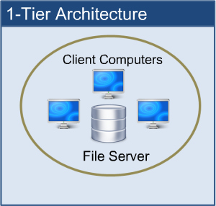All users run their programs from a single machine. The ease with which deployment and even development occurs makes this model very attractive. The cost of the central machine makes this architecture prohibitive for most companies, especially as system costs and return on investment (ROI) are looked at carefully nowadays.

# CHAPTER NO- 4

# Software and Hardware Requirements

#### Software Requirements

|  |  |  |
| --- | --- | --- |
| **Sr.**  **No.** | **Name of Resource** | **Specifications** |
| **1.** | Operating System | Windows 10 |
| 2. | Software | MYSQL DBMS,  NetBeans IDE 7.1.2 |

#### 4.1 Software Requirements

* 1. **Hardware Requirements**

|  |  |  |
| --- | --- | --- |
| **Sr.**  **No.** | **Name of Resource** | **Specifications** |
| **1.** | Computer system | Intel (R) core (TM) i3-4170 CPU@ 3.20GHz |
| **2.** | Primary Memory | 4GB |
| **3.** | Secondary Memory | 1TB HDD, 128 SSD |

**4.2 Hardware Requirements**

**CHAPTER – 5**

**Implementation Details**

**5.1 FRONT – END AND BACK-END**

In their most general meanings, the terms front end and back end refer to the initial and the end stages of a process flow. In [software design](http://en.wikipedia.org/wiki/Software_design), the **front-end** is the part of a software system that deals with the user, and the **back-end** is the part that processes the input from the front-end. The separation of software systems into "front ends" and "back ends" is a kind of [abstraction](http://en.wikipedia.org/wiki/Abstraction_(computer_science)) that helps to keep different parts of the system separated. The general idea is that the front-end is responsible for collecting input from the user, which can be in a variety of forms, and processing it in such a way that it conforms to a specification that the back-end can use. The connection of the front-end to the back-end is a kind of [interface](http://en.wikipedia.org/wiki/Interface).

Front-end and back-end are terms used to characterize program interfaces and services relative to the initial user of these interfaces and services. (The "user" may be a human being or a program.) A ”front-end” [application](http://searchwebservices.techtarget.com/sDefinition/0,,sid26_gci211585,00.html) is one that application users interact with directly. A "back-end" application or program serves indirectly in support of the front-end services, usually by being closer to the required resource or having the capability to communicate with the required resource. The back-end application may interact directly with the front-end or, perhaps more typically, is a program called from an intermediate program that mediates front-end and back-end activities. These terms acquire more special meanings in particular areas:-

(1) For [software applications](http://www.webopedia.com/TERM/f/application.html), front end is the same as [user interface](http://www.webopedia.com/TERM/f/user_interface.html).

(2) In [client/server](http://www.webopedia.com/TERM/f/client_server_architecture.html) applications, the [client part](http://www.webopedia.com/TERM/f/client.html) of the [program](http://www.webopedia.com/TERM/f/program.html) is often called the front end and the server part is called the back end.

(3) [Compilers](http://www.webopedia.com/TERM/f/compiler.html), the programs that translate [source code](http://www.webopedia.com/TERM/f/source_code.html) into [object code](http://www.webopedia.com/TERM/f/object_code.html), are often composed of two parts: a front end and a back end. The front end is responsible for checking [syntax](http://www.webopedia.com/TERM/f/syntax.html) and detecting errors, whereas the back end performs the actual translation into object code.

**5.2 Data Base Tables**

This project uses many tables:

* Admin
* Voter
* Candidate

**5.2.1 Admin Table**

|  |  |  |
| --- | --- | --- |
| Field Name | Data Type | Description |
| Username | varchar | Login id for Admin. (Primary key) |
| Password | varchar | Password for Login |

**5.2.1 Admin Table**

**5.2.2 Voter Table**

|  |  |  |
| --- | --- | --- |
| Field Name | Data Type | Description |
| VoterId | Integer | Login id for Voter(Primary key) |
| Name | Varchar | Name of the voter |
| Sex | Varchar | Sex of voter |
| Age | Integer | Age of voter |
| City | Varchar | City of voter |
| Security | Varchar | Security Question |
| Status | Boolean | Status of voter(he/she can vote or not) |

**5.2.3 Voter Table**

**5.2.3 Candidate Table**

|  |  |  |
| --- | --- | --- |
| Field Name | Data Type | Description |
| Symbol | Varchar | Party Symbol (Primary key) |
| Name | Varchar | Name of the voter |
| Sex | Varchar | Sex of voter |
| Age | Integer | Age of voter |
| City | Varchar | City of voter |
| Count | Integer | Count the no of votes |

**5.2.3 Candidate Table**

**5.3 ER Diagram:**

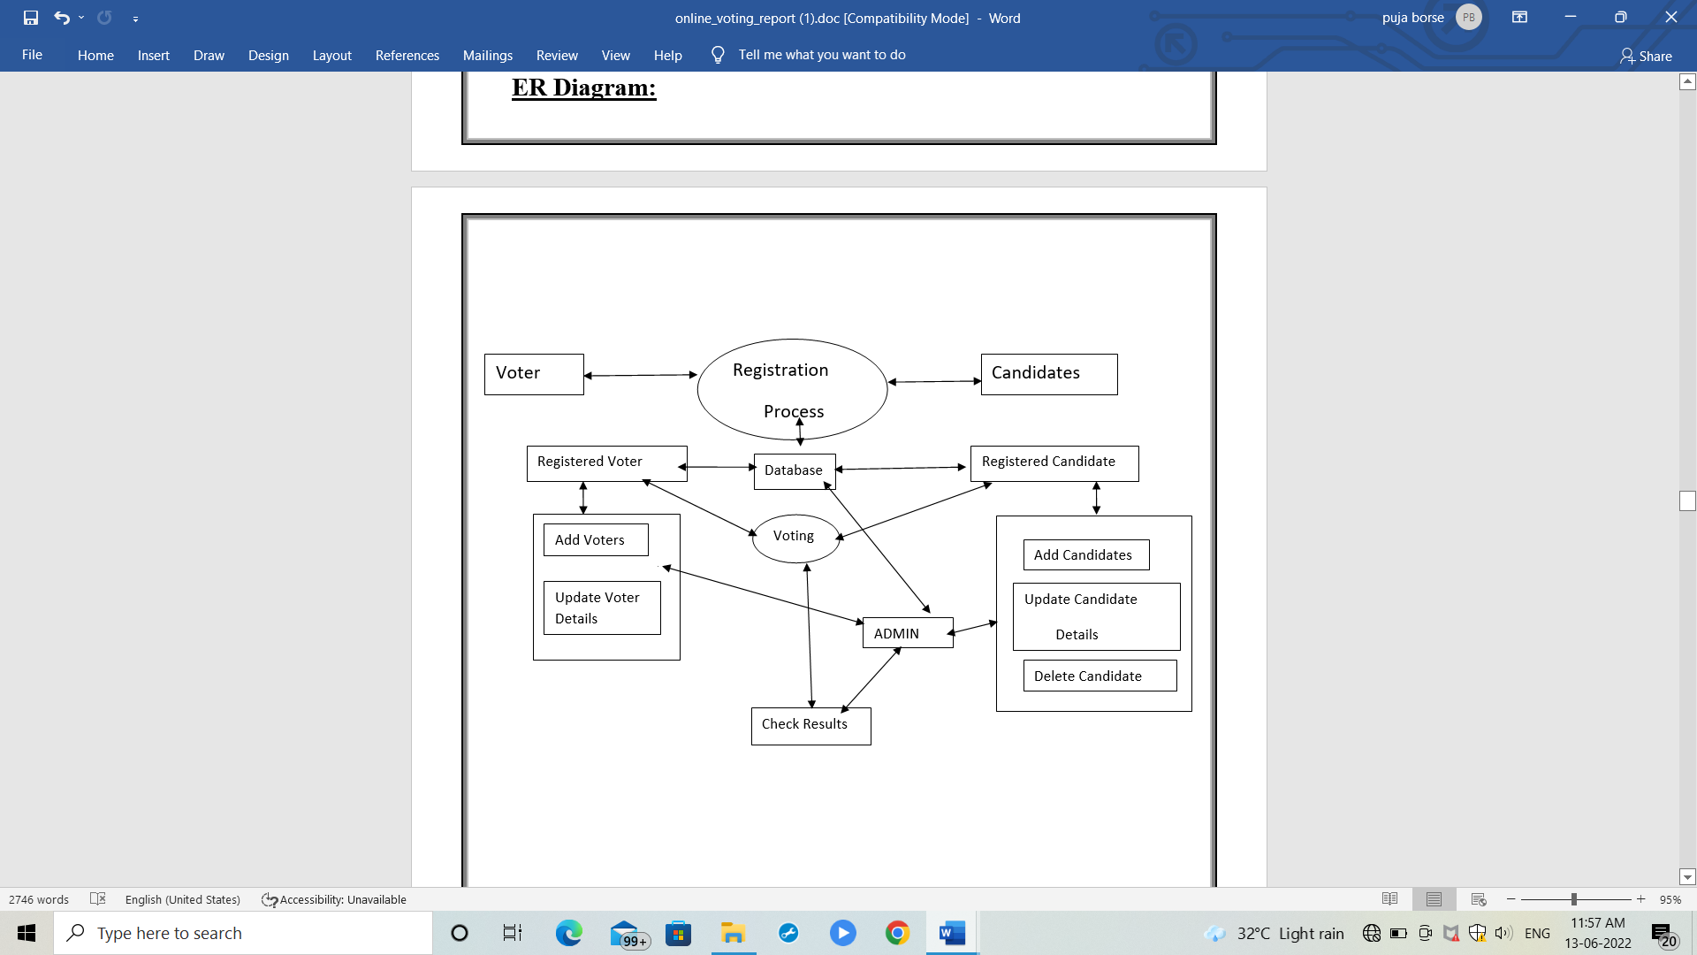

* 1. **ER Diagram**

#### 5.4 Outputs

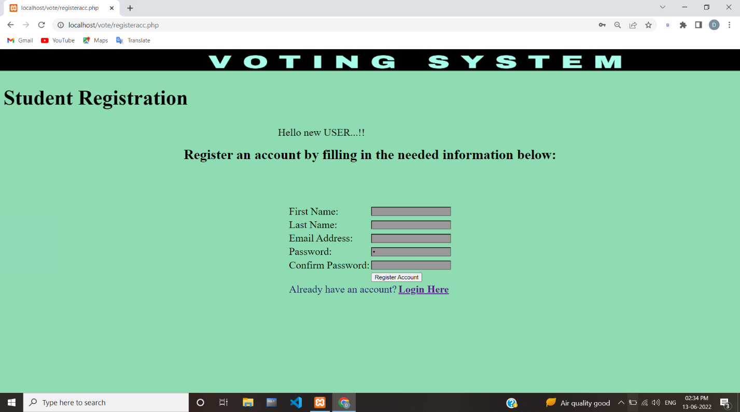**5.4.1 Snapshot Of Log In Page**

**5.4.2 Registration Page**

#### 

#### Snapshot of Home Page.

#### 5.4.4 Voting Page

#### 5.5 Advantages

### Increased Efficiency

### Improved Accuracy

### Greater Turnout And Voter Engagement

### Verifiable ballots

### Certified election results

### Reduced costs

### On-demand Paper Ballots

### Ability to correct mistakes

**CHAPTER – 5**

**Conclusions**

This Online Voting system will manage the Voter’s information by which voter can login and use his voting rights. The system will incorporate all features of Voting system. It provides the tools for maintaining voter’s vote to every party and it count total no. of votes of every party. There is a DATABASE which is maintained by the ELECTION COMMISION OF INDIA in which all the names of voter with complete information is stored.

In this user who is above 18 year’s register his/her information on the database and when he/she want to vote he/she has to login by his id and password and can vote to any party only single time. Voting detail store in database and the result is displayed by calculation. By online voting system percentage of voting is increases. It decreases the cost and time of voting process. It is very easy to use and It is vary less time consuming. It is very easy to debug.

### BIBLIOGRAPHY

*[ 1 ]* [*https://right2vote.in/*](https://right2vote.in/)

*[2] https://www.eballot.com/votes-and-elections/what-is-an-online-voting-system*

*[ 3]* [*https://transmitter.ieee.org/makerproject/view/91d35*](https://transmitter.ieee.org/makerproject/view/91d35)

*[4]* [*https://www.polyas.com/online-voting/how-it-works*](https://www.polyas.com/online-voting/how-it-works)

*[5]* [*https://medium.com/edge-elections/what-is-online-voting-d46cf7e5a152*](https://medium.com/edge-elections/what-is-online-voting-d46cf7e5a152)

*[6]* [*https://www.w3schools.com/php/*](https://www.w3schools.com/php/)

*[7]* [*https://www.guru99.com/php-tutorials.html*](https://www.guru99.com/php-tutorials.html)

*[8]* [*https://javascript.info/*](https://javascript.info/)

*[9]https://developer.mozilla.org/enUS/docs/Learn/Getting_started_with_the_web/*